Name: _____________________ Class:__________ Date:__________
Instructions: Write answers in the right-hand column. Score: ___________ / 50 marks
Section A—Multiple choice (10 marks)

 | Identify which of the following is the best definition of a mineral.  A naturally occurring liquid or solid in the Earth’s crust, excluding petroleum and coal  B chemical compound found in the Earth’s crust  C compound that forms crystals as it cools  D rock that contains a high level of a particular valuable chemical compound | A | 1
 | Choose a suitable definition of an ore.  A mineral that is particularly valuable and worth mining  B rock that contains a high level of a valuable mineral  C deposit in the crust that is economically valuable  D a rock that contains valuable metals that can be extracted | B | 1
 | Gold found in cracks in igneous rocks was usually deposited there by:  A underground rivers.  B cooling magma.  C hydrothermal fluids.  D evaporation of water | C | 1
 | In which of the following ways did oil and gas form?  A Plants that fell into the swamps were covered by sediment and high pressure, heat and a lack of oxygen changed their body chemicals into oil and gas.  B Heat deep in the Earth slowly changed the chemicals in the bodies of dead microscopic organisms into compounds high in carbon.  C Plants that fell into magma became burned to a black charcoal and this gradually turned into oil and gas when the rock set hard.  D High temperature and pressure deep in the Earth produced new minerals from those in the igneous and sedimentary rocks that sank into the mantle. | B | 1
 | A seismic survey works by:  A setting an explosive charge in the rocks and collecting the rocks blasted out.  B drilling out a core of rock and chemically testing it for mineral content.  C creating a shock wave in the rock and seeing how much it makes the ground shake.  D sending a shock wave into the Earth and watching for how it reflects off rock layers below. | D | 1
 | A geological map is useful in mining because it:  A gives a 3D picture of the ore bodies so that mining engineers can decide how best to mine the ore.  B can give a cross section of the minerals in the rocks and so it helps decide where to drill test holes  C tells geologists exactly how much the ore in an area is worth and helps them decide if it is worth drilling test holes there.  D helps geologists see where they can build their roads out to where the mine sites will be. | A | 1
 | Satellite images of the ground are useful in exploration because they:  A show miners the best places build the roads, towns and minesite.  B can show minerals that cannot be seen with visible light.  C can show large areas of ground at once and this helps to quickly decide on a good place to mine.  D can show the ground in different colours and this makes it easier to work out what the ground surface is like. | B | 1
 | State the three main factors that determine what type of mining method is chosen.  A whether there is a town nearby, what the roads are like and is the mineral valuable enough  B what country the mineral is in, how much it would cost to transport workers to the site and whether the environment could be harmed  C the type of mineral, the geology of the area and the economics of mining that particular mineral  D if it is on a hill, near the surface or in one small area | C | 1
 | Rehabilitation of a minesite would generally involve checking the water drainage of the area, replacing the topsoil, fertilising the soil and planting with plants native to the area. The main reason why government environmental regulations require this is to:  A ensure that the community will continue to accept miners in their area.  B provide jobs for the local community.  C make sure the mining company cannot be fined for damaging the environment.  D reduce the amount of soil erosion and return the area at close to its original condition. | D | 1
 | Which of the following is the best description of leach mining?  A A large pit is dug and filled with groundwater to create a small lake, then a dredge is floated on the surface and this sucks up the sediments.  B Two vertical shafts are dug into an ore body. Then water is pumped into one shaft and a big hose sucks the soil out of the other shaft.  C A drill hole is bored into the rock layers where the deposit is found and when the hole fills with ground water, it is pumped to the surface.  D A hole is drilled into the ore deposit and a solution that will dissolve the ore is pumped in, then the dissolved mineral is pumped back to the surface. | D | 1

Section B— Short answer (30 marks)

- ` | Compare a rock, a mineral and an ore. | Rocks are solid mixtures of several different chemical compounds called minerals. A mineral is a chemical compound found in rocks. If the rock is fairly high in the mineral then the rock is called an ore—a source of the mineral that could be extracted profitably. Many rocks are not ores because they contain no valuable mineral that we want to extract. | 3
 | Explain how minerals may form in cracks in rocks through the action of hydrothermal fluids. | Hydrothermal fluids are hot fluids from deep in the Earth that rise into the crust carrying dissolved minerals and dissolving some as they flow. The fluid flows through cracks in the rock. As they cool, these fluids deposit minerals in the cracks. | 3
 | Imagine you are given two large black crystals. Describe three different tests you could do to compare these two crystals to decide if they are different minerals or the same mineral. | You could scrape them on an unglazed white tile to see their streak colour. If it is the same, they could be the same mineral. If it is different, they cannot be the same mineral.  You could also grind them to a powder and heat them in a flame to see the flame colour—different colour means probably different minerals.  You could try testing the hardness using Mohs scale. Scratching with materials of known hardness can show if they have similar or different hardness. Different hardness would mean different minerals. | 6
 | Distinguish between aeromagnetic surveys and aerial gravity surveys. | Aeromagnetic surveys detect the changes in the magnetic field of the Earth and the affect minerals have on it whereas aerial gravity surveys detect small differences in the gravitational pull of the Earth. | 2
 | Describe three situations in which a mining company would choose open pit rather than underground mining. | Open pit is cheaper when the ore body is:  1 near the surface  2 of low grade  3 spread over a large area. | 3
 | Consider the ore body shown in the diagram.  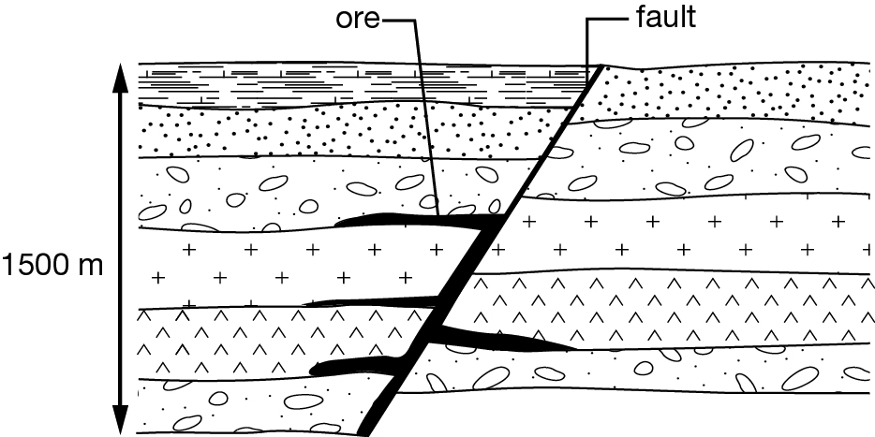  Decide on a suitable mining method to mine the ore body and explain why it is a suitable method. | Underground mining using a vertical shaft and then horizontal shafts along the horizontal parts of the ore body. It is a very deep and concentrated ore body, so it would be cheaper to use shafts than to use open cut. | 3
 | Modify the following definitions to make them correct.  a petroleum: coal, oil and natural gas found in the Earth’s crust  b streak: the colour when the mineral is crushed to a powder  c magnetic survey: measuring the effect of applying a magnetic field to the Earth  d seismic survey: sending a magnetic field into the ground surface and recording the reflected waves | a petroleum: oil and natural gas found in the Earth’s crust  b streak: the colour when the mineral is scratched on an unglazed white tile  c magnetic surveys: measuring the effect of rocks on the magnetic field of the Earth  d seismic surveys: involve sending a sound wave into the ground surface, and recording the reflected waves | 4
 | Explain what is meant by ‘tailings’ and why storing tailings in earth dams can be a problem. | Tailings are the waste left after the mineral has been extracted. They can be toxic and storing them in dams has caused problems when some dams have burst. | 2
 | The process of obtaining minerals, petroleum or coal from the ground in the form required generally consists of four main steps. Describe each step. | • Explore: searching for the rocks containing the minerals, coal or petroleum  • Mine it or remove it from the ground  • Enrich (or concentrate) it, which involves increasing how much there is of the mineral, coal or petroleum in a particular volume of the removed material  • Extract which is a chemical process of removing the element needed from the compound in which it occurs. | 4

Section C— Thinking scientifically (10 marks)

Information for Questions 1 and 2
Consider the diagram below showing two situations in which oil may migrate through rocks.
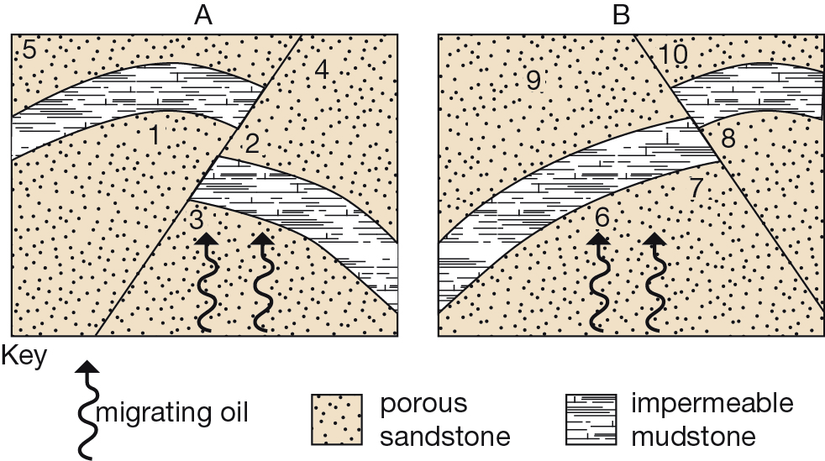
 | Predict where the oil will end up in Diagram A  A 1  B 2  C 3  D 4 | d | 1
 | Predict where oil will end up in Diagram B  A 6  B 7  C 8  D 9 | C | 1
 | Study the four diagrams below, which show the structure and orientation of four different ore bodies. The diagrams are to scale and the bottom of each diagram represents a depth of 1000 metres.  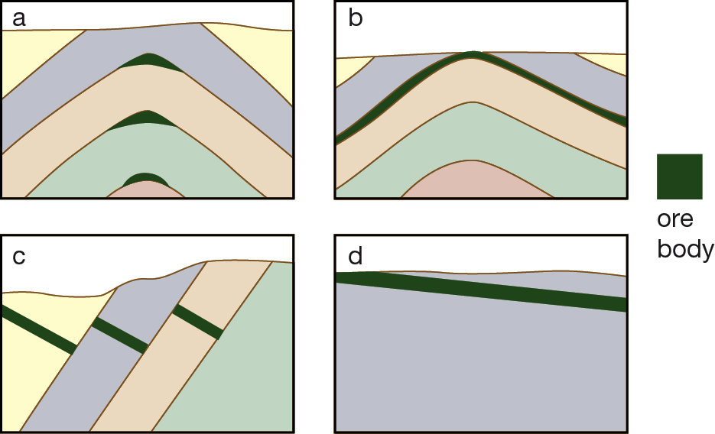  Which of the ore bodies is most suitable for open cut mining?  A a  B b  C c  D d | D | 1
 | Information for Questions 4 and 5  The flow chart below shows the processes (in a simplified way) used to separate valuable minerals from beach sand. Study it carefully before answering the following questions.  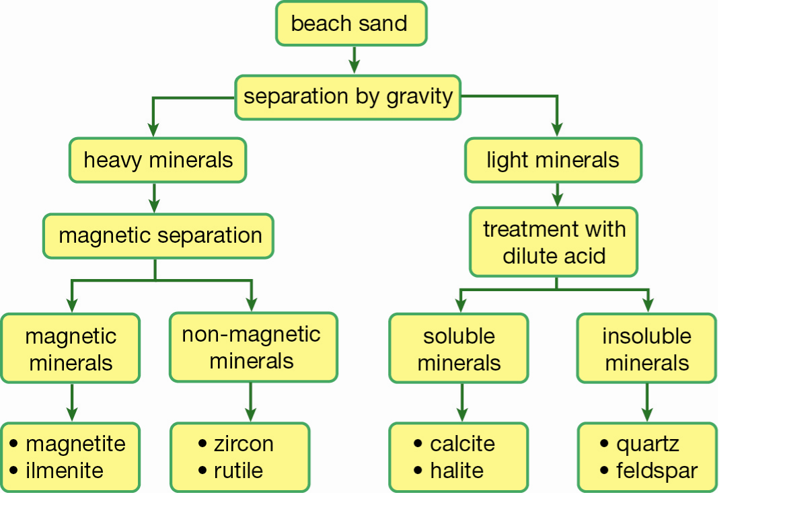 |  | 1
 | Identify the properties of ilmenite based on the key.  A a heavy, magnetic material  B found in beach sand and can be separated from other minerals by using a magnet  C a magnetic material soluble in dilute acid  D a beach sand that is heavy and that does not react with acid | A | 1
 | Identify a likely mining method used with these mineral sands.  A open cut  B underground  C dredging  D adits | C | 1
 | Why is gold profitable to mine even when it is found in small amounts, whereas copper has to occur in large quantities to be worth mining?  A People like gold more than copper and so gold always brings higher prices.  B Copper is not as rare as gold and therefore cheaper, so the copper ore body must be large to make a profit.  C Gold is found on the surface and open cut mines are cheaper to run than underground mines.  D Copper is much harder to mine than gold because it does not occur in big ore bodies. | B | 1
 | A field geologist finds a mineral she does not immediately recognise, so she tries to establish how hard it is. She has a field hardness kit consisting of a copper coin (hardness 3.5), a penknife (hardness 5.5), a small piece of glass (hardness 6) and a crystal of quartz (hardness 7). The geologist discovers that she can scratch the unknown mineral with the piece of glass, but the mineral actually scratches her penknife. The hardness of the mineral is:  A between 5 and 6  B 5.5  C 6  D between 5.5 and 6 | D | 1
 | Fool’s gold (iron pyrites) and gold are a similar colour, and many people are often fooled by the appearance. However, when a streak test is done, fool’s gold has a greenish black streak and gold has the same colour streak as the lump of gold. What can be concluded from this example?  A gold and fool’s gold are the same mineral but with a different structure  B the streak test did not prove these two minerals were the same  C streak tests are very unreliable to use as a means of deciding if two minerals are different  D the streak test can show that two minerals are different | D | 1
 | Why would a geochemical survey of groundwater not necessarily be a good indicator of the minerals in the rocks surrounding the water?  A The water may have flowed there from somewhere else and been there only a short while.  B Water cannot be tested to search for minerals that are in rocks because water does not dissolve rocks.  C If the water is very hot it may be depositing minerals in the surrounding rocks.  D The water will not dissolve every type of mineral out of the surrounding rocks so it would not give a true picture of what is there. | A | 1
 | Coal mines can be dangerous places to work, because poisonous and explosive gases can be released from the coal as it is mined. This means it is particularly important to:  A know about the chemistry of coal.  B know and follow all the safety rules.  C never have accidents that can injure you.  D do what your friends in the mine tell you to. | B | 1

